**Logical modelling of E-comm**

We already found the entities , attributes and their basic relationship before in the requirement analysis.Now we will also point out its entities, attributes and their basic relationship with ER diagrams for more convenience and understandability purposes for ourselves and for our clients.

The different entities of our models are:

1. Product
2. Category
3. Brand
4. Customer
5. Shipping address
6. Payment
7. Cart
8. Order
9. OrderDetails
10. Reviews

**Business rules**

* Product should have its name , category , stock,price and brand.
* Products can only be associated with a single category and brand.While a category and brand can have multiple products .
* Payment can only be done either by ESEWA or the option cash on delivery can be selected.
* Customer should have its id, name, phone number , email address , and his/her possible address and its shipping address.The shipping address can also be provided during the checkout process.
* The customers can have only a single address while they can have multiple shipping addresses.
* Items and their quantity can be added to the cart if the product is in stock.
* Cart can be proceeded to checkouts.
* Customers can add reviews to the product.
* Products can have multiple order_details.order_details can have only one Product.
* Order can have multiple order_details.And order_details can have only one order.
* Products can have no or multiple reviews by the customers.

Entity Relationship Diagram

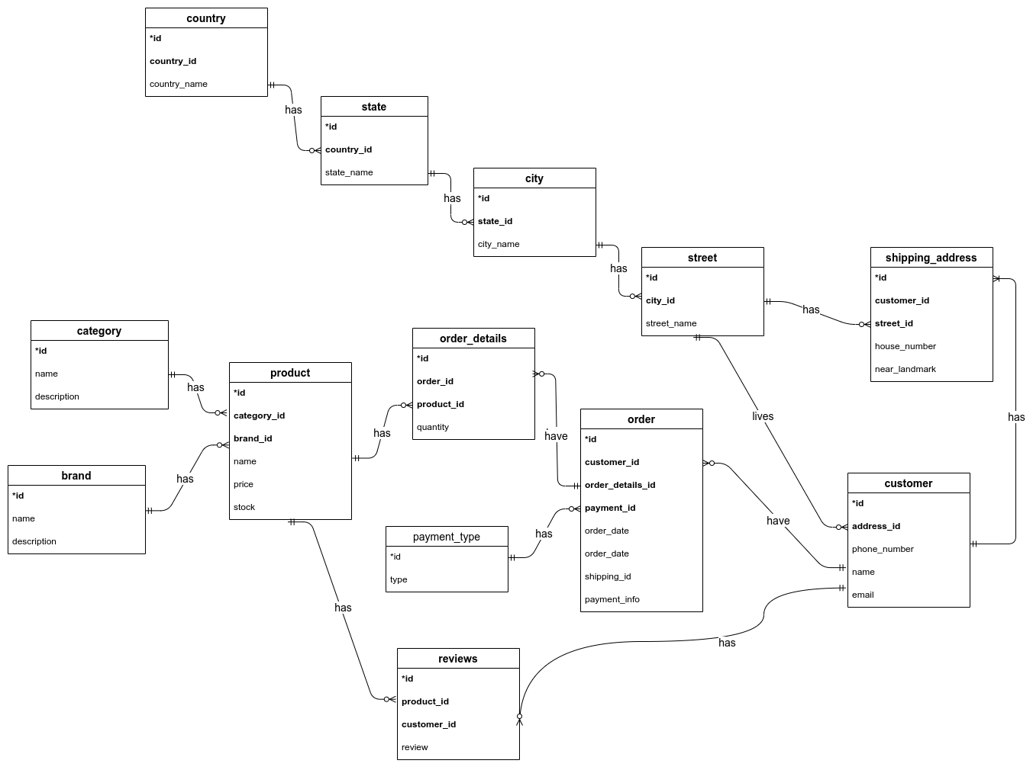

*Fig: ER diagram of E-comm*

**Verification**

After building the ER , now I tried to verify it and going through it I found the Fan-Trap problem.

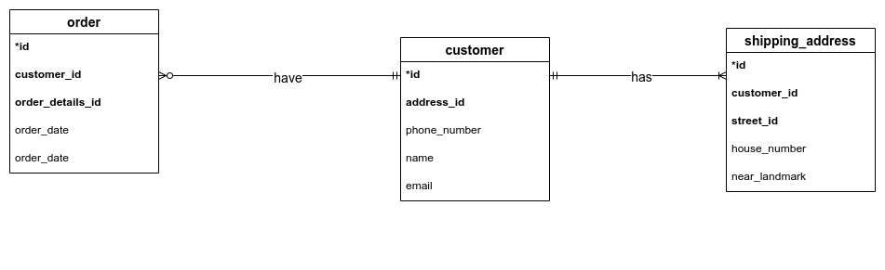

*Fig: Fan-Trap of above ER model of E-comm*

So, we can solve these problems by reconstructing the ER model to represent the correct association among the entities.

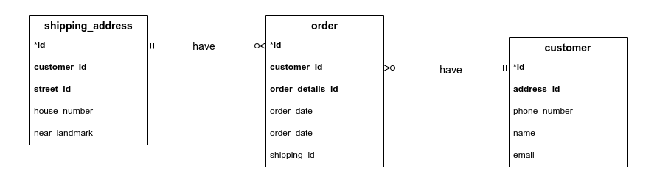

*Fig: Fan-Trap solution of above ER model of E-comm*

After the above correction our ER diagram becomes:

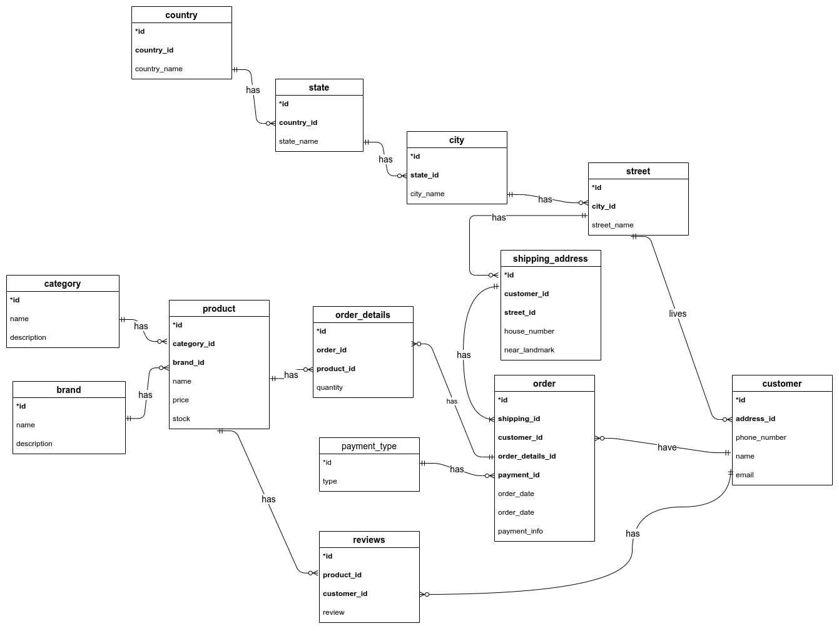

*Fig: ER diagram of E-comm*

**References**:

1. Draw.io (for ER diagram)